Answer 3
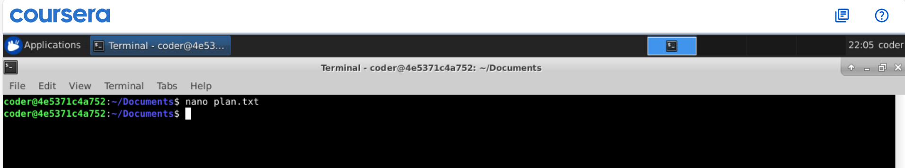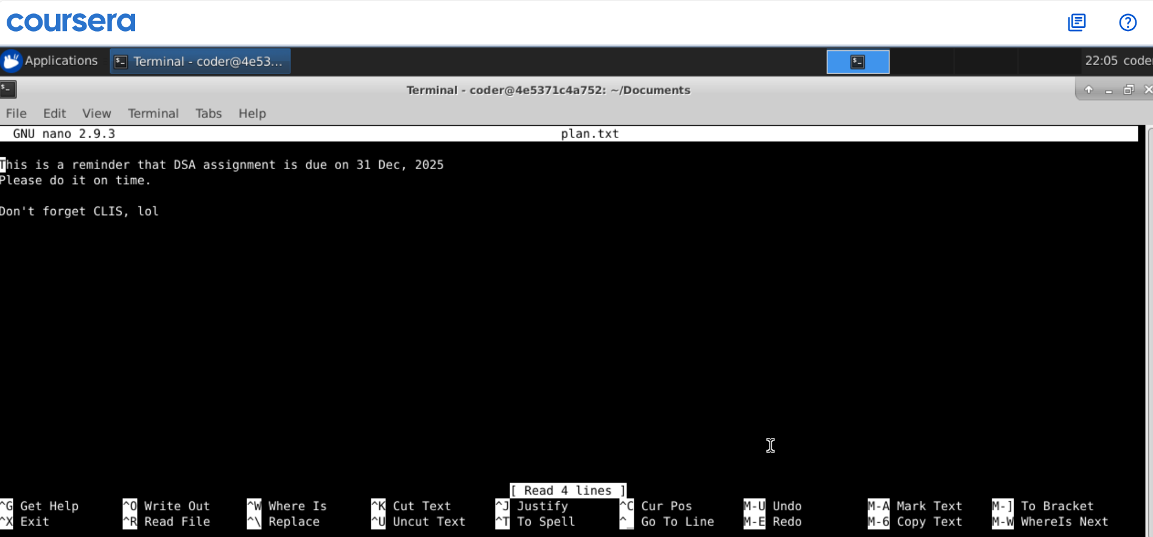
Explanation: I have added text using nano paln.txt command, it can be also done using vi text editor with vi plan.txt command. Also, we could use echo “Text here ” >> plan.txt.

